SUMMER READING/DISCOVERY PROGRAMS
Wednesdays at 10:30 am -- Preschool Storytime
Thursdays at 10:30 am -- Imagineers (Ages 6-8 years)
Thursdays at 2 pm -- TWEENS (Ages 9-13 years)

KIDS CRAFTERNOONS
Tuesdays at 2:00 pm -- Craft time for ages 6-8 years
Tuesdays at 3:30 pm – Craft time for ages 9-13 years

Reading Program
Reading logs may be picked up at the library beginning Thursday, June 2nd, and must be completed and returned to the library by Thursday, July 7th.
Children may select books from the library or from other sources to read. To be eligible for the program, they must keep a reading log that lists the title of the books read or a time log that lists how much time they spent reading. Non-readers who wish to participate may have parents read and keep logs for them
For more information, please call the library at 936-598-5522.
FANNIE BROWN BOOTH
MEMORIAL LIBRARY PRESENTS
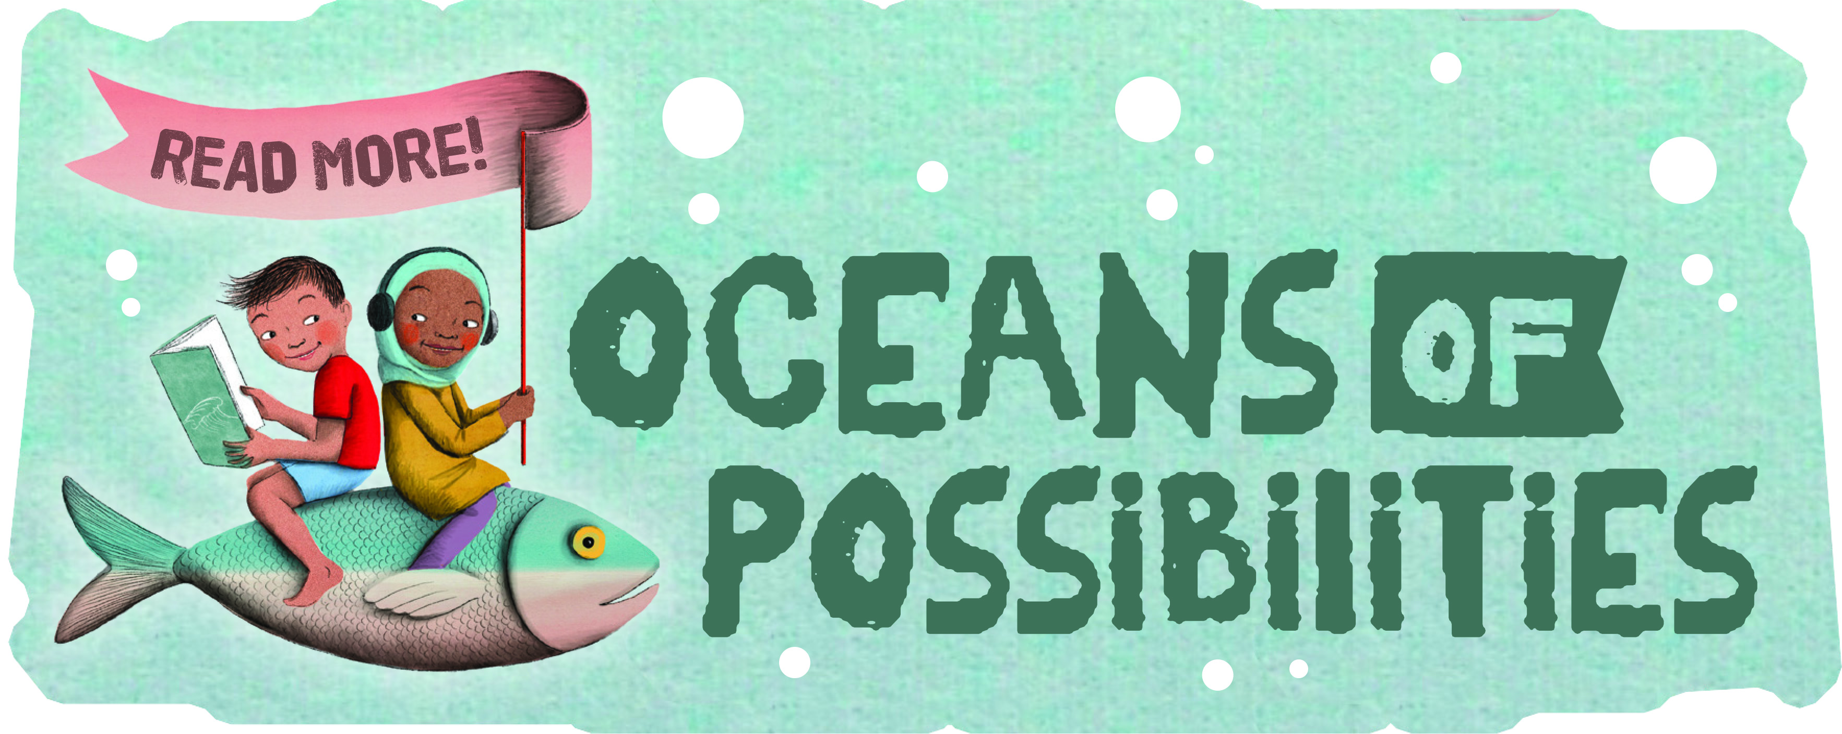
2022 Summer Reading/Discovery Program
June 2 – July 7th
Join us this summer for an epic underwater adventure!
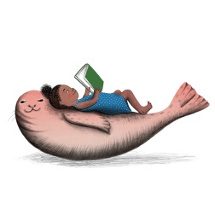
The Summer Reading/Discovery Program
is sponsored by the
CENTER NOON LIONS CLUB!
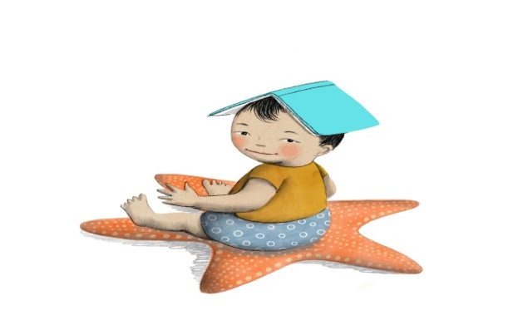
Thursdays@10:30 am
Imagineers (Ages 6-8)
June 2 – (Anytime) Pick-up packets and schedules
June 9 – Sea Turtles (Keep our Oceans Clean)
June 16 – Dolphins
June 23 – Pirates and Mermaids
June 30 – Shark Week!
July 7 – Magician David Gish
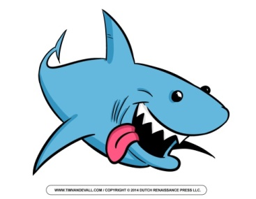
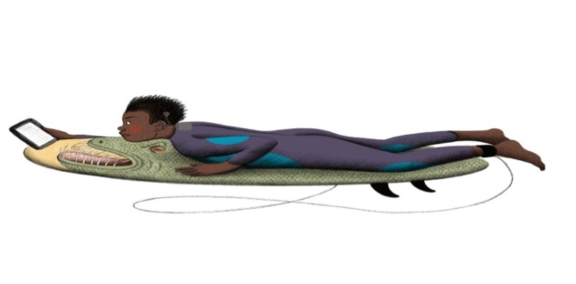
Thursdays@2:00 pm
‘Tweens (Ages 9-13)
June 2 – (Anytime) Pick-up packets and schedules
June 9 – Scuba Diving/ Underwater Exploring
June 16 – Dolphins
June 23 – Shipwreck/ Survival
June 30 -- Shark Week!
July 7 – 10:30 am Magician David Gish
